BootCamp NEO4J
Alvaro Monteiro
Vitória-ES, 07/11/2025
Entrega Projeto 1
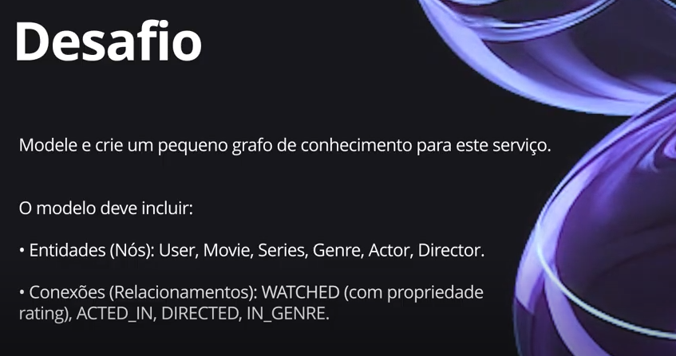
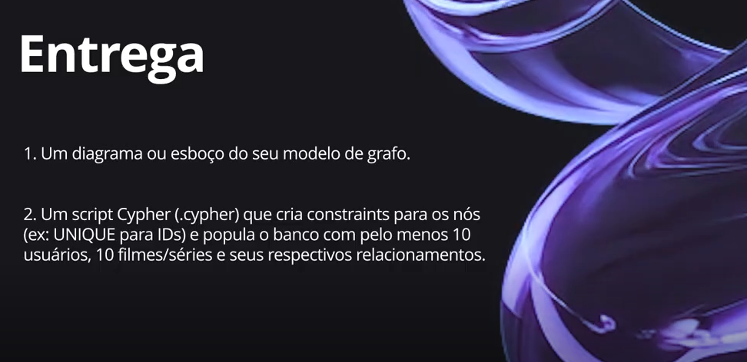

Abaixo vemos a imagem do diagrama em algumas figuras, pois o diagrama ficou um pouco grande
Falando sobre o produto entregue no desafio
Temos:
- 17 filmes
- 6 séries
- 6 gêneros
- 22 atores
- 22 diretores
- 21 usuários
- Nós = 115
- Relações = 92

Imagem geral feita por query no banco NEO4J, com script refatorado do Arrows App.

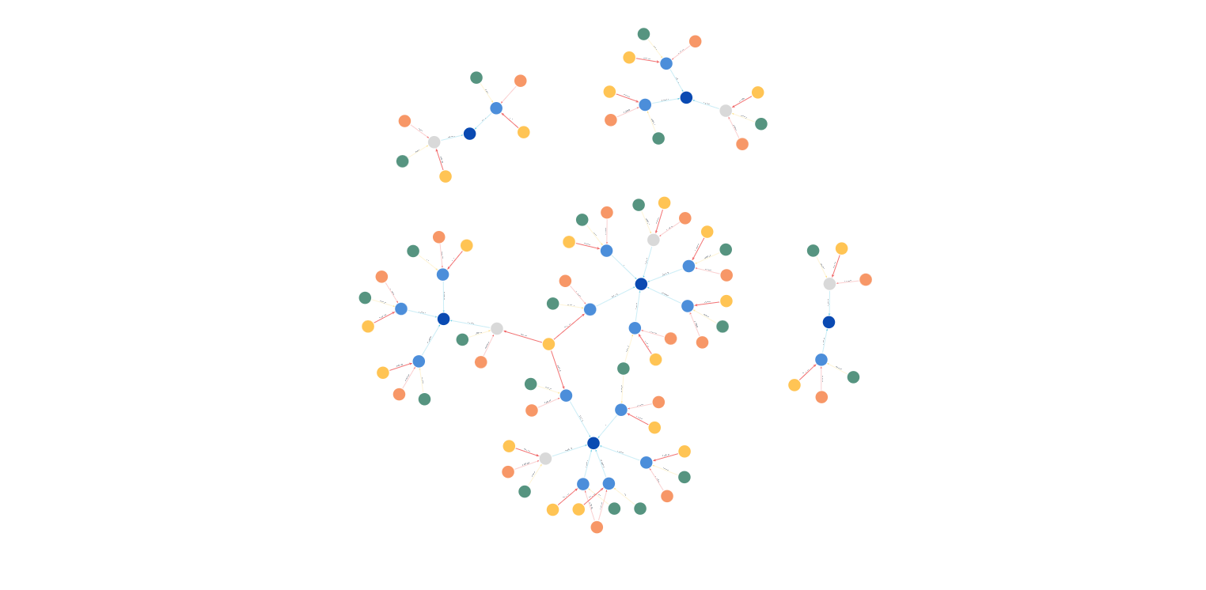

Imagem de uma visão mais próxima
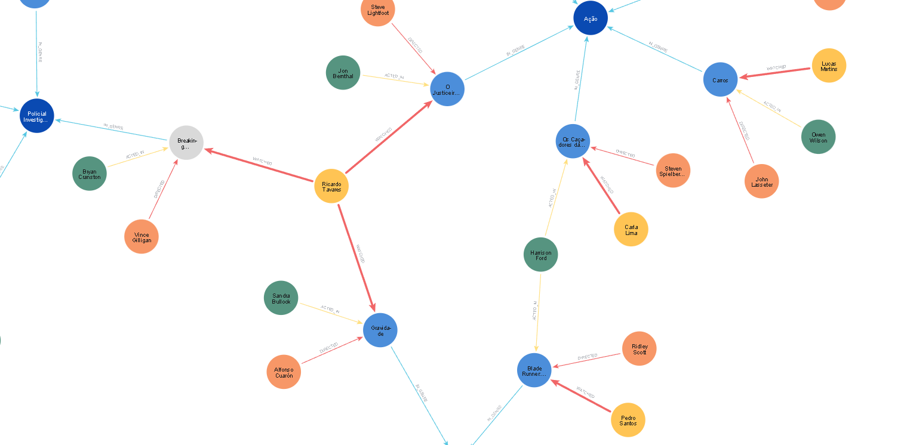

Imagem de um usuário especifico que contém 3 títulos

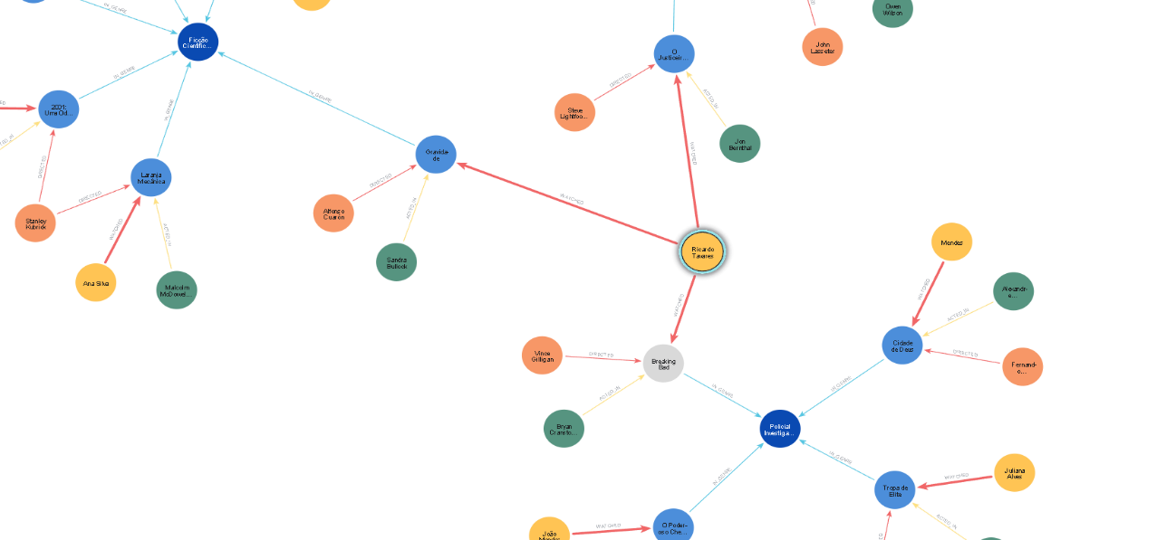
Projeto desenhado no Arrow App

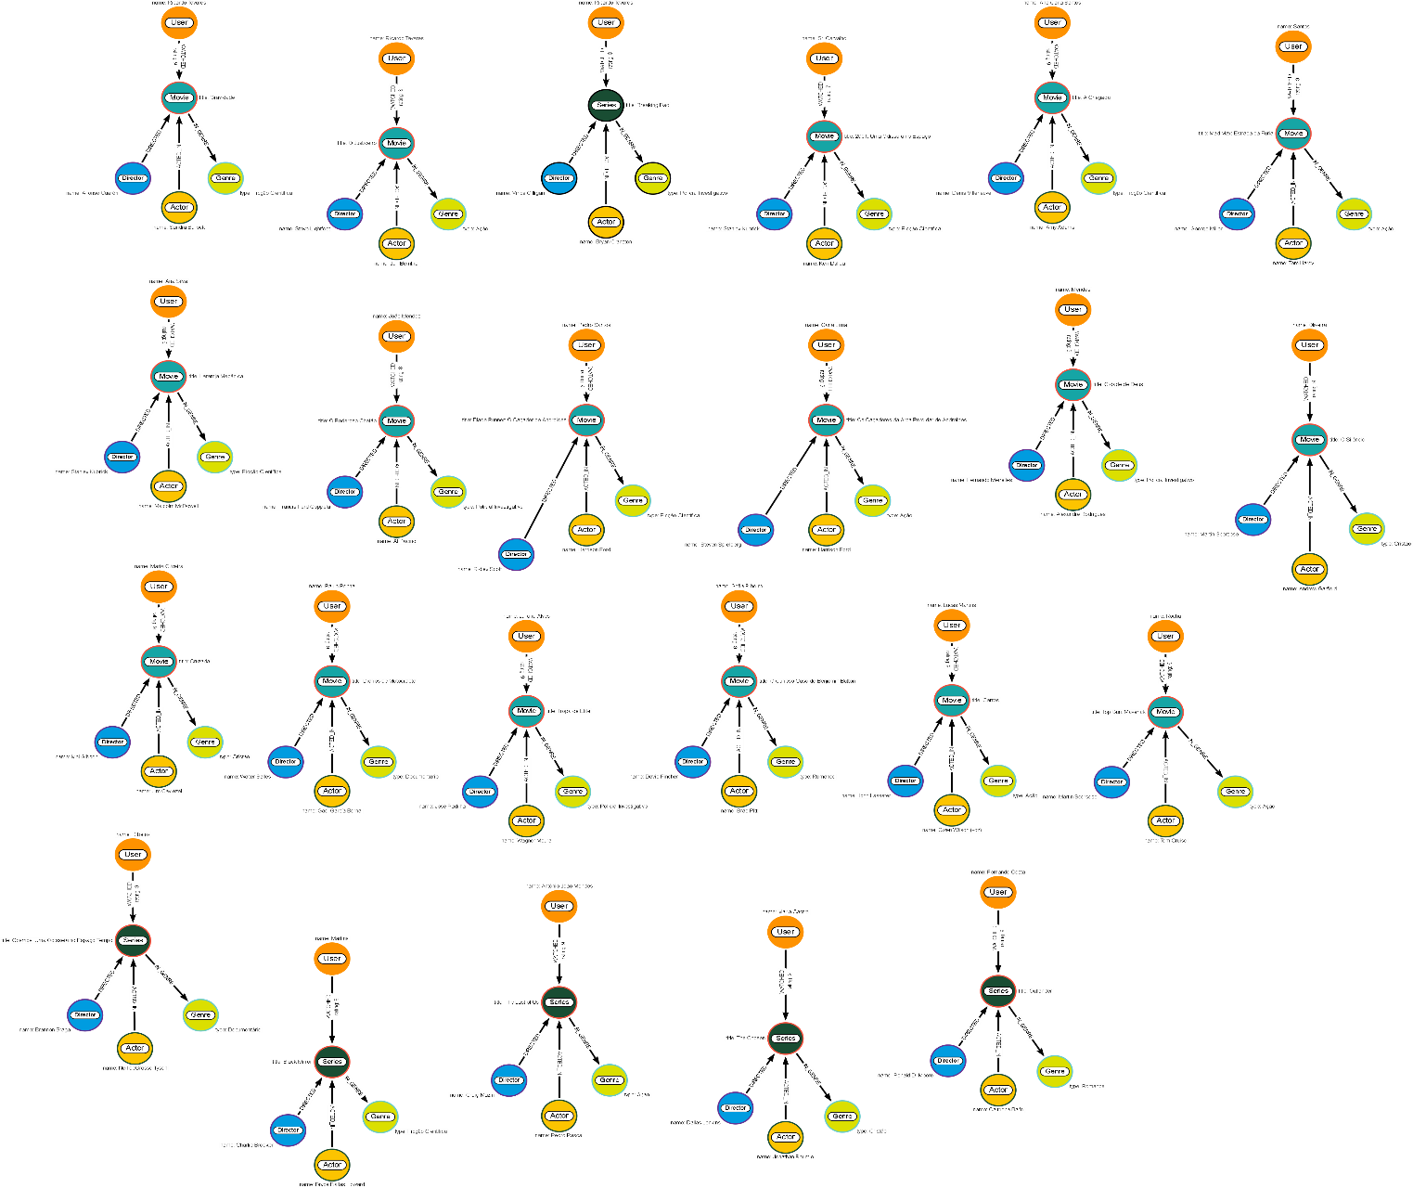

Script gerado pelo Arrow App

CREATE (:Director {name: "Vince Gilligan"})-[:DIRECTED]->(n5:Series {title: "Breaking Bad"})<-[:ACTED_IN]-(:Actor {name: "Bryan Cranston"}),
(:User {name: "Ricardo Tavares"})-[:WATCHED {rating: 8}]->(n5)-[:IN_GENRE]->(:Genre {type: "Policial Investigativo"}),
(:Actor {name: "Sandra Bullock"})-[:ACTED_IN]->(n10:Movie {title: "Gravidade"})<-[:DIRECTED]-(:Director {name: "Alfonso Cuarón"}),
(:User {name: "Ricardo Tavares"})-[:WATCHED {rating: 8}]->(n14:Movie {title: "O Justiceiro"})-[:IN_GENRE]->(:Genre {type: "Ação"}),
(:Actor {name: "Jon Bernthal"})-[:ACTED_IN]->(n14)<-[:DIRECTED]-(:Director {name: "Steve Lightfoot"}),
(:User {name: "Sr. Carvalho"})-[:WATCHED {rating: 7}]->(n19:Movie {title: "2001: Uma Odisseia no Espaço"})<-[:ACTED_IN]-(:Actor {name: "Keir Dullea"}),
(:Director {name: "Stanley Kubrick"})-[:DIRECTED]->(n19)-[:IN_GENRE]->(:Genre {type: "Ficção Científica"}),
(:User {name: "Ricardo Tavares"})-[:WATCHED {rating: 9}]->(n10)-[:IN_GENRE]->(:Genre {type: "Ficção Científica"}),
(:Actor {name: "Malcolm McDowell"})-[:ACTED_IN]->(n26:Movie {title: "Laramja Mecânica"})<-[:DIRECTED]-(:Director {name: "Stanley Kubrick"}),
(:User {name: "Ana Silva"})-[:WATCHED {rating: 9}]->(n26)-[:IN_GENRE]->(:Genre {type: "Ficção Científica"}),
(:User {name: "João Mendes"})-[:WATCHED {rating: 8}]->(n32:Movie {title: "O Poderoso Chefão"})-[:IN_GENRE]->(:Genre {type: "Policial Investigativo"}),
(:Actor {name: "Al Pacino"})-[:ACTED_IN]->(n32)<-[:DIRECTED]-(:Director {name: "Francis Ford Coppola"}),
(:Actor {name: "Harrison Ford"})-[:ACTED_IN]->(n36:Movie {title: "Blade Runner: O Caçador de Androides"})<-[:DIRECTED]-(:Director {name: "Ridley Scott"}),
(:User {name: "Pedro Santos"})-[:WATCHED {rating: 9}]->(n36)-[:IN_GENRE]->(:Genre {type: "Ficção Científica"}),
(:Actor {name: "Harrison Ford"})-[:ACTED_IN]->(n41:Movie {title: "Os Caçadores da Arca Perdidar de Androides"})<-[:DIRECTED]-(:Director {name: "Steven Spielberg"}),
(:User {name: "Carla Lima"})-[:WATCHED {rating: 9}]->(n41)-[:IN_GENRE]->(:Genre {type: "Ação"}),
(:Actor {name: "Jim Caviezel"})-[:ACTED_IN]->(n46:Movie {title: "Cruzada"})<-[:DIRECTED]-(:Director {name: "Mel Gibson"}),
(:User {name: "Maria Oliveira"})-[:WATCHED {rating: 9}]->(n46)-[:IN_GENRE]->(:Genre {type: "Cristão"}),
(:Actor {name: "Gael García Bernal"})-[:ACTED_IN]->(n52:Movie {title: "Diários de Motocicleta"})<-[:DIRECTED]-(:Director {name: "Walter Salles"}),
(:User {name: "Paulo Rocha"})-[:WATCHED {rating: 9}]->(n52)-[:IN_GENRE]->(:Genre {type: "Documentário"}),
(:Actor {name: "Wagner Moura"})-[:ACTED_IN]->(n57:Movie {title: "Tropa de Elite"})<-[:DIRECTED]-(:Director {name: "José Padilha"}),
(:User {name: "Juliana Alves"})-[:WATCHED {rating: 9}]->(n57)-[:IN_GENRE]->(:Genre {type: "Policial Investigativo"}),
(:Actor {name: "Brad Pitt"})-[:ACTED_IN]->(n62:Movie {title: "O Curioso Caso de Benjamin Button"})<-[:DIRECTED]-(:Director {name: "David Fincher"}),
(:User {name: "Sofia Ribeiro"})-[:WATCHED {rating: 9}]->(n62)-[:IN_GENRE]->(:Genre {type: "Romance"}),
(:Actor {name: "Owen Wilson (voz)"})-[:ACTED_IN]->(n67:Movie {title: "Carros"})<-[:DIRECTED]-(:Director {name: "John Lasseter"}),
(:User {name: "Lucas Martins"})-[:WATCHED {rating: 9}]->(n67)-[:IN_GENRE]->(:Genre {type: "Ação"}),
(:Actor {name: "Amy Adams"})-[:ACTED_IN]->(n72:Movie {title: "A Chegada"})<-[:DIRECTED]-(:Director {name: "Denis Villeneuve"}),
(:User {name: "Ana Carla Santos"})-[:WATCHED {rating: 9}]->(n72)-[:IN_GENRE]->(:Genre {type: "Ficção Científica"}),
(:Actor {name: "Alexandre Rodrigues"})-[:ACTED_IN]->(n77:Movie {title: "Cidade de Deus"})<-[:DIRECTED]-(:Director {name: "Fernando Meirelles"}),
(:User {name: "Mendes"})-[:WATCHED {rating: 9}]->(n77)-[:IN_GENRE]->(:Genre {type: "Policial Investigativo"}),
(:Actor {name: "Tom Hardy"})-[:ACTED_IN]->(n82:Movie {title: "Mad Max: Estrada da Fúria"})<-[:DIRECTED]-(:Director {name: "George Miller"}),
(:User {name: "Santos"})-[:WATCHED {rating: 9}]->(n82)-[:IN_GENRE]->(:Genre {type: "Ação"}),
(:Actor {name: "Andrew Garfield"})-[:ACTED_IN]->(n87:Movie {title: "O Silêncio"})<-[:DIRECTED]-(:Director {name: "Martin Scorsese"}),
(:User {name: "Oliveira"})-[:WATCHED {rating: 7}]->(n87)-[:IN_GENRE]->(:Genre {type: "Cristão"}),
(:Actor {name: "Jonathan Roumie"})-[:ACTED_IN]->(n92:Series {title: "The Chosen"})<-[:DIRECTED]-(:Director {name: "Dallas Jenkins"}),
(:User {name: "Maria Castro"})-[:WATCHED {rating: 9}]->(n92)-[:IN_GENRE]->(:Genre {type: "Cristão"}),
(:Actor {name: "Neil deGrasse Tyson"})-[:ACTED_IN]->(n97:Series {title: "Cosmos: Uma Odisseia no Espaço-Tempo"})<-[:DIRECTED]-(:Director {name: "Brannon Braga"}),
(:User {name: "Ribeiro"})-[:WATCHED {rating: 9}]->(n97)-[:IN_GENRE]->(:Genre {type: "Documentário"}),
(:Actor {name: "Tom Cruise"})-[:ACTED_IN]->(n102:Movie {title: "Top Gun: Maverick"})<-[:DIRECTED]-(:Director {name: "Martin Scorsese"}),
(:User {name: "Rocha"})-[:WATCHED {rating: 8}]->(n102)-[:IN_GENRE]->(:Genre {type: "Ação"}),
(:Actor {name: "Bryce Dallas Howard"})-[:ACTED_IN]->(n107:Series {title: "Black Mirror"})<-[:DIRECTED]-(:Director {name: "Charlie Brooker"}),
(:User {name: "Martins"})-[:WATCHED {rating: 9}]->(n107)-[:IN_GENRE]->(:Genre {type: "Ficção Científica"}),
(:Actor {name: "Pedro Pascal"})-[:ACTED_IN]->(n112:Series {title: "The Last of Us"})<-[:DIRECTED]-(:Director {name: "Craig Mazin"}),
(:User {name: "Antônio João Mendes"})-[:WATCHED {rating: 9}]->(n112)-[:IN_GENRE]->(:Genre {type: "Ação"}),
(:Actor {name: "Caitríona Balfe"})-[:ACTED_IN]->(n117:Series {title: "Outlander"})<-[:DIRECTED]-(:Director {name: "Ronald D. Moore"}),
(:User {name: "Fernando Costa"})-[:WATCHED {rating: 9}]->(n117)-[:IN_GENRE]->(:Genre {type: "Romance"});

Visualização do modelo de grafo no banco NEO4J com o script gerado no Arrow APP.
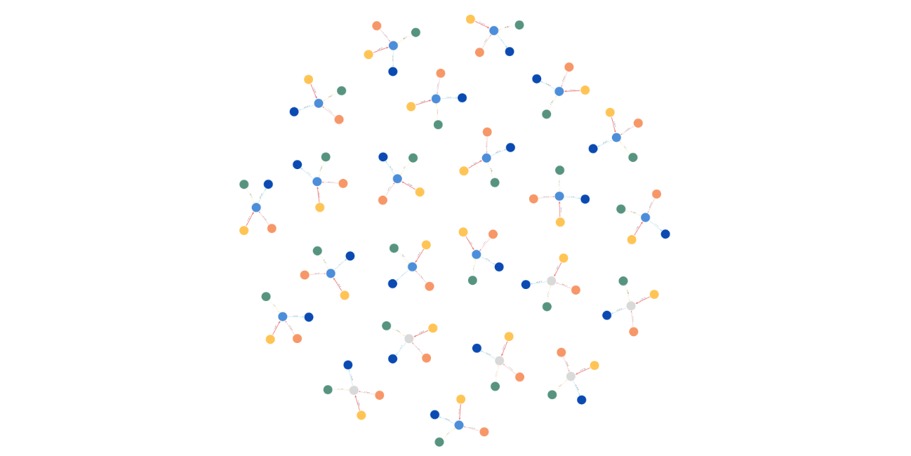

Mesmo grafo um pouco mais perto.

Verificamos que foram recriados 3 vezes o mesmo usuário tal qual o desenho do Arrows APP, neste modelo de grafo não temos a visualização de produto cartesiano das entidades gênero, diretor, usuário, pois ocorreu a repetição tal qual foi feita no desenho.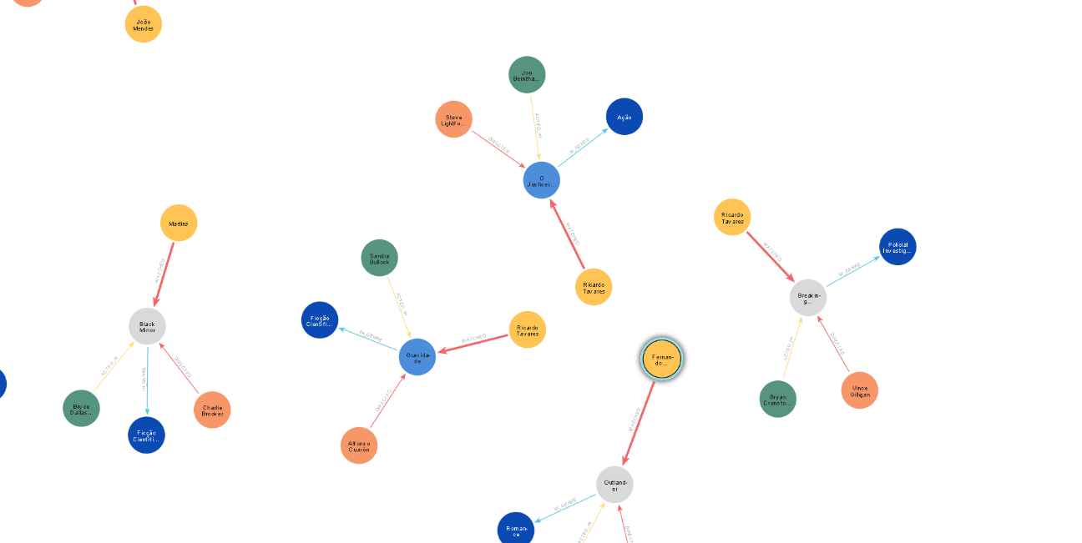

Script refatorado para apresentação do trabalho.

// LIMPAR O BANCO PRIMEIRO
MATCH (n) DETACH DELETE n;

// CRIAR GÊNEROS
CREATE
(:Genre {type: "Ficção Científica"}),
(:Genre {type: "Policial Investigativo"}),
(:Genre {type: "Ação"}),
(:Genre {type: "Cristão"}),
(:Genre {type: "Documentário"}),
(:Genre {type: "Romance"});

// CRIAR DIRETORES
CREATE
(:Director {name: "Vince Gilligan"}),
(:Director {name: "Alfonso Cuarón"}),
(:Director {name: "Steve Lightfoot"}),
(:Director {name: "Stanley Kubrick"}),
(:Director {name: "Francis Ford Coppola"}),
(:Director {name: "Ridley Scott"}),
(:Director {name: "Steven Spielberg"}),
(:Director {name: "Mel Gibson"}),
(:Director {name: "Walter Salles"}),
(:Director {name: "José Padilha"}),
(:Director {name: "David Fincher"}),
(:Director {name: "John Lasseter"}),
(:Director {name: "Denis Villeneuve"}),
(:Director {name: "Fernando Meirelles"}),
(:Director {name: "George Miller"}),
(:Director {name: "Dallas Jenkins"}),
(:Director {name: "Brannon Braga"}),
(:Director {name: "Charlie Brooker"}),
(:Director {name: "Craig Mazin"}),
(:Director {name: "Ronald D. Moore"}),
(:Director {name: "Martin Scorsese"}),
(:Director {name: "Joseph Kosinski"});

// CRIAR ATORES
CREATE
(:Actor {name: "Bryan Cranston"}),
(:Actor {name: "Sandra Bullock"}),
(:Actor {name: "Jon Bernthal"}),
(:Actor {name: "Keir Dullea"}),
(:Actor {name: "Malcolm McDowell"}),
(:Actor {name: "Al Pacino"}),
(:Actor {name: "Harrison Ford"}),
(:Actor {name: "Jim Caviezel"}),
(:Actor {name: "Gael García Bernal"}),
(:Actor {name: "Wagner Moura"}),
(:Actor {name: "Brad Pitt"}),
(:Actor {name: "Owen Wilson"}),
(:Actor {name: "Amy Adams"}),
(:Actor {name: "Alexandre Rodrigues"}),
(:Actor {name: "Tom Hardy"}),
(:Actor {name: "Andrew Garfield"}),
(:Actor {name: "Jonathan Roumie"}),
(:Actor {name: "Neil deGrasse Tyson"}),
(:Actor {name: "Tom Cruise"}),
(:Actor {name: "Bryce Dallas Howard"}),
(:Actor {name: "Pedro Pascal"}),
(:Actor {name: "Caitríona Balfe"});

// CRIAR USUÁRIOS
CREATE
(:User {name: "Ricardo Tavares"}),
(:User {name: "Sr. Carvalho"}),
(:User {name: "Ana Silva"}),
(:User {name: "João Mendes"}),
(:User {name: "Pedro Santos"}),
(:User {name: "Carla Lima"}),
(:User {name: "Maria Oliveira"}),
(:User {name: "Paulo Rocha"}),
(:User {name: "Juliana Alves"}),
(:User {name: "Sofia Ribeiro"}),
(:User {name: "Lucas Martins"}),
(:User {name: "Ana Carla Santos"}),
(:User {name: "Mendes"}),
(:User {name: "Santos"}),
(:User {name: "Oliveira"}),
(:User {name: "Maria Castro"}),
(:User {name: "Ribeiro"}),
(:User {name: "Rocha"}),
(:User {name: "Martins"}),
(:User {name: "Antônio João Mendes"}),
(:User {name: "Fernando Costa"});

// AGORA CRIAR FILMES, SÉRIES E RELACIONAMENTOS COM REFERÊNCIAS EXPLÍCITAS
// Breaking Bad
MATCH (d:Director {name: "Vince Gilligan"})
MATCH (a:Actor {name: "Bryan Cranston"})
MATCH (g:Genre {type: "Policial Investigativo"})
MATCH (u:User {name: "Ricardo Tavares"})
CREATE (bb:Series {title: "Breaking Bad"})
CREATE (d)-[:DIRECTED]->(bb)
CREATE (a)-[:ACTED_IN]->(bb)
CREATE (bb)-[:IN_GENRE]->(g)
CREATE (u)-[:WATCHED {rating: 8}]->(bb);

// Gravidade
MATCH (d:Director {name: "Alfonso Cuarón"})
MATCH (a:Actor {name: "Sandra Bullock"})
MATCH (g:Genre {type: "Ficção Científica"})
MATCH (u:User {name: "Ricardo Tavares"})
CREATE (m:Movie {title: "Gravidade"})
CREATE (d)-[:DIRECTED]->(m)
CREATE (a)-[:ACTED_IN]->(m)
CREATE (m)-[:IN_GENRE]->(g)
CREATE (u)-[:WATCHED {rating: 9}]->(m);

// O Justiceiro
MATCH (d:Director {name: "Steve Lightfoot"})
MATCH (a:Actor {name: "Jon Bernthal"})
MATCH (g:Genre {type: "Ação"})
MATCH (u:User {name: "Ricardo Tavares"})
CREATE (m:Movie {title: "O Justiceiro"})
CREATE (d)-[:DIRECTED]->(m)
CREATE (a)-[:ACTED_IN]->(m)
CREATE (m)-[:IN_GENRE]->(g)
CREATE (u)-[:WATCHED {rating: 8}]->(m);

// 2001: Uma Odisseia no Espaço
MATCH (d:Director {name: "Stanley Kubrick"})
MATCH (a:Actor {name: "Keir Dullea"})
MATCH (g:Genre {type: "Ficção Científica"})
MATCH (u:User {name: "Sr. Carvalho"})
CREATE (m:Movie {title: "2001: Uma Odisseia no Espaço"})
CREATE (d)-[:DIRECTED]->(m)
CREATE (a)-[:ACTED_IN]->(m)
CREATE (m)-[:IN_GENRE]->(g)
CREATE (u)-[:WATCHED {rating: 7}]->(m);

// Laranja Mecânica
MATCH (d:Director {name: "Stanley Kubrick"})
MATCH (a:Actor {name: "Malcolm McDowell"})
MATCH (g:Genre {type: "Ficção Científica"})
MATCH (u:User {name: "Ana Silva"})
CREATE (m:Movie {title: "Laranja Mecânica"})
CREATE (d)-[:DIRECTED]->(m)
CREATE (a)-[:ACTED_IN]->(m)
CREATE (m)-[:IN_GENRE]->(g)
CREATE (u)-[:WATCHED {rating: 9}]->(m);

// O Poderoso Chefão
MATCH (d:Director {name: "Francis Ford Coppola"})
MATCH (a:Actor {name: "Al Pacino"})
MATCH (g:Genre {type: "Policial Investigativo"})
MATCH (u:User {name: "João Mendes"})
CREATE (m:Movie {title: "O Poderoso Chefão"})
CREATE (d)-[:DIRECTED]->(m)
CREATE (a)-[:ACTED_IN]->(m)
CREATE (m)-[:IN_GENRE]->(g)
CREATE (u)-[:WATCHED {rating: 8}]->(m);

// Blade Runner
MATCH (d:Director {name: "Ridley Scott"})
MATCH (a:Actor {name: "Harrison Ford"})
MATCH (g:Genre {type: "Ficção Científica"})
MATCH (u:User {name: "Pedro Santos"})
CREATE (m:Movie {title: "Blade Runner: O Caçador de Androides"})
CREATE (d)-[:DIRECTED]->(m)
CREATE (a)-[:ACTED_IN]->(m)
CREATE (m)-[:IN_GENRE]->(g)
CREATE (u)-[:WATCHED {rating: 9}]->(m);

// Os Caçadores da Arca Perdida
MATCH (d:Director {name: "Steven Spielberg"})
MATCH (a:Actor {name: "Harrison Ford"})
MATCH (g:Genre {type: "Ação"})
MATCH (u:User {name: "Carla Lima"})
CREATE (m:Movie {title: "Os Caçadores da Arca Perdida"})
CREATE (d)-[:DIRECTED]->(m)
CREATE (a)-[:ACTED_IN]->(m)
CREATE (m)-[:IN_GENRE]->(g)
CREATE (u)-[:WATCHED {rating: 9}]->(m);

// Cruzada
MATCH (d:Director {name: "Mel Gibson"})
MATCH (a:Actor {name: "Jim Caviezel"})
MATCH (g:Genre {type: "Cristão"})
MATCH (u:User {name: "Maria Oliveira"})
CREATE (m:Movie {title: "Cruzada"})
CREATE (d)-[:DIRECTED]->(m)
CREATE (a)-[:ACTED_IN]->(m)
CREATE (m)-[:IN_GENRE]->(g)
CREATE (u)-[:WATCHED {rating: 9}]->(m);

// Diários de Motocicleta
MATCH (d:Director {name: "Walter Salles"})
MATCH (a:Actor {name: "Gael García Bernal"})
MATCH (g:Genre {type: "Documentário"})
MATCH (u:User {name: "Paulo Rocha"})
CREATE (m:Movie {title: "Diários de Motocicleta"})
CREATE (d)-[:DIRECTED]->(m)
CREATE (a)-[:ACTED_IN]->(m)
CREATE (m)-[:IN_GENRE]->(g)
CREATE (u)-[:WATCHED {rating: 9}]->(m);

// Tropa de Elite
MATCH (d:Director {name: "José Padilha"})
MATCH (a:Actor {name: "Wagner Moura"})
MATCH (g:Genre {type: "Policial Investigativo"})
MATCH (u:User {name: "Juliana Alves"})
CREATE (m:Movie {title: "Tropa de Elite"})
CREATE (d)-[:DIRECTED]->(m)
CREATE (a)-[:ACTED_IN]->(m)
CREATE (m)-[:IN_GENRE]->(g)
CREATE (u)-[:WATCHED {rating: 9}]->(m);

// Benjamin Button
MATCH (d:Director {name: "David Fincher"})
MATCH (a:Actor {name: "Brad Pitt"})
MATCH (g:Genre {type: "Romance"})
MATCH (u:User {name: "Sofia Ribeiro"})
CREATE (m:Movie {title: "O Curioso Caso de Benjamin Button"})
CREATE (d)-[:DIRECTED]->(m)
CREATE (a)-[:ACTED_IN]->(m)
CREATE (m)-[:IN_GENRE]->(g)
CREATE (u)-[:WATCHED {rating: 9}]->(m);

// Carros
MATCH (d:Director {name: "John Lasseter"})
MATCH (a:Actor {name: "Owen Wilson"})
MATCH (g:Genre {type: "Ação"})
MATCH (u:User {name: "Lucas Martins"})
CREATE (m:Movie {title: "Carros"})
CREATE (d)-[:DIRECTED]->(m)
CREATE (a)-[:ACTED_IN]->(m)
CREATE (m)-[:IN_GENRE]->(g)
CREATE (u)-[:WATCHED {rating: 9}]->(m);

// A Chegada
MATCH (d:Director {name: "Denis Villeneuve"})
MATCH (a:Actor {name: "Amy Adams"})
MATCH (g:Genre {type: "Ficção Científica"})
MATCH (u:User {name: "Ana Carla Santos"})
CREATE (m:Movie {title: "A Chegada"})
CREATE (d)-[:DIRECTED]->(m)
CREATE (a)-[:ACTED_IN]->(m)
CREATE (m)-[:IN_GENRE]->(g)
CREATE (u)-[:WATCHED {rating: 9}]->(m);

// Cidade de Deus
MATCH (d:Director {name: "Fernando Meirelles"})
MATCH (a:Actor {name: "Alexandre Rodrigues"})
MATCH (g:Genre {type: "Policial Investigativo"})
MATCH (u:User {name: "Mendes"})
CREATE (m:Movie {title: "Cidade de Deus"})
CREATE (d)-[:DIRECTED]->(m)
CREATE (a)-[:ACTED_IN]->(m)
CREATE (m)-[:IN_GENRE]->(g)
CREATE (u)-[:WATCHED {rating: 9}]->(m);

// Mad Max
MATCH (d:Director {name: "George Miller"})
MATCH (a:Actor {name: "Tom Hardy"})
MATCH (g:Genre {type: "Ação"})
MATCH (u:User {name: "Santos"})
CREATE (m:Movie {title: "Mad Max: Estrada da Fúria"})
CREATE (d)-[:DIRECTED]->(m)
CREATE (a)-[:ACTED_IN]->(m)
CREATE (m)-[:IN_GENRE]->(g)
CREATE (u)-[:WATCHED {rating: 9}]->(m);

// The Chosen (Série)
MATCH (d:Director {name: "Dallas Jenkins"})
MATCH (a:Actor {name: "Jonathan Roumie"})
MATCH (g:Genre {type: "Cristão"})
MATCH (u:User {name: "Maria Castro"})
CREATE (s:Series {title: "The Chosen"})
CREATE (d)-[:DIRECTED]->(s)
CREATE (a)-[:ACTED_IN]->(s)
CREATE (s)-[:IN_GENRE]->(g)
CREATE (u)-[:WATCHED {rating: 9}]->(s);

// Cosmos (Série)
MATCH (d:Director {name: "Brannon Braga"})
MATCH (a:Actor {name: "Neil deGrasse Tyson"})
MATCH (g:Genre {type: "Documentário"})
MATCH (u:User {name: "Ribeiro"})
CREATE (s:Series {title: "Cosmos: Uma Odisseia no Espaço-Tempo"})
CREATE (d)-[:DIRECTED]->(s)
CREATE (a)-[:ACTED_IN]->(s)
CREATE (s)-[:IN_GENRE]->(g)
CREATE (u)-[:WATCHED {rating: 9}]->(s);

// Black Mirror (Série)
MATCH (d:Director {name: "Charlie Brooker"})
MATCH (a:Actor {name: "Bryce Dallas Howard"})
MATCH (g:Genre {type: "Ficção Científica"})
MATCH (u:User {name: "Martins"})
CREATE (s:Series {title: "Black Mirror"})
CREATE (d)-[:DIRECTED]->(s)
CREATE (a)-[:ACTED_IN]->(s)
CREATE (s)-[:IN_GENRE]->(g)
CREATE (u)-[:WATCHED {rating: 9}]->(s);

// The Last of Us (Série)
MATCH (d:Director {name: "Craig Mazin"})
MATCH (a:Actor {name: "Pedro Pascal"})
MATCH (g:Genre {type: "Ação"})
MATCH (u:User {name: "Antônio João Mendes"})
CREATE (s:Series {title: "The Last of Us"})
CREATE (d)-[:DIRECTED]->(s)
CREATE (a)-[:ACTED_IN]->(s)
CREATE (s)-[:IN_GENRE]->(g)
CREATE (u)-[:WATCHED {rating: 9}]->(s);

// Outlander (Série)
MATCH (d:Director {name: "Ronald D. Moore"})
MATCH (a:Actor {name: "Caitríona Balfe"})
MATCH (g:Genre {type: "Romance"})
MATCH (u:User {name: "Fernando Costa"})
CREATE (s:Series {title: "Outlander"})
CREATE (d)-[:DIRECTED]->(s)
CREATE (a)-[:ACTED_IN]->(s)
CREATE (s)-[:IN_GENRE]->(g)
CREATE (u)-[:WATCHED {rating: 9}]->(s);

// O Silêncio (Filme)
MATCH (d:Director {name: "Martin Scorsese"})
MATCH (a:Actor {name: "Andrew Garfield"})
MATCH (g:Genre {type: "Cristão"})
MATCH (u:User {name: "Oliveira"})
CREATE (m:Movie {title: "O Silêncio"})
CREATE (d)-[:DIRECTED]->(m)
CREATE (a)-[:ACTED_IN]->(m)
CREATE (m)-[:IN_GENRE]->(g)
CREATE (u)-[:WATCHED {rating: 7}]->(m);

// Top Gun: Maverick (Filme)
MATCH (d:Director {name: "Joseph Kosinski"})
MATCH (a:Actor {name: "Tom Cruise"})
MATCH (g:Genre {type: "Ação"})
MATCH (u:User {name: "Rocha"})
CREATE (m:Movie {title: "Top Gun: Maverick"})
CREATE (d)-[:DIRECTED]->(m)
CREATE (a)-[:ACTED_IN]->(m)
CREATE (m)-[:IN_GENRE]->(g)
CREATE (u)-[:WATCHED {rating: 8}]->(m);

MATCH p=()-[]->() RETURN p LIMIT 450;

Conclusão:

O script do Arrow App cria exatamente a estrutura do desenho feito no app, ou seja, temos redundâncias de entidades.

Já o script refatorado cria a imagem que apresentamos acima, nesta imagem podemos ver que temos o produto cartesiano feito da relação de gênero x diretor e ainda de diretor x filme, logo temos um menor número de entidades.

Acreditamos que para o trabalho em questão podemos observar as versões e aplicações dos 2 scripts.

Arquivos:

Scripts:

Arrows App original

Arrows App refatorado

